**Assignment 3B**

**Index: server.js**

const express = require("express");

const bodyParser = require("body-parser");

const app = express();

app.use(bodyParser.urlencoded({ extended: true }));

app.use(bodyParser.json());

const UserRoute = require("./routes/User");

app.use("/user", UserRoute);

const dbConfig = require("./config/database.config.js");

const mongoose = require("mongoose");

mongoose.Promise = global.Promise;

mongoose

.connect(dbConfig.url, {

useNewUrlParser: true,

})

.then(() => {

console.log("Databse Connected Successfully!!");

})

.catch((err) => {

console.log("Could not connect to the database", err);

process.exit();

});

app.get("/", (req, res) => {

res.json({ message: "Hello Crud Node Express" });

});

app.listen(3000, () => {

console.log("Server is listening on port 3000");

});

**Routes: User.js**

const express = require("express");

const UserController = require("../controllers/User");

const router = express.Router();

router.get("/", UserController.findAll);

router.get("/:id", UserController.findOne);

router.post("/", UserController.create);

router.patch("/:id", UserController.update);

router.delete("/:id", UserController.destroy);

module.exports = router;

**Model: User.js**

var mongoose = require("mongoose");

var schema = new mongoose.Schema({

email: { type: String, required: true, unique: true },

firstName: { type: String, default: "" },

lastName: { type: String, default: "" },

phone: String,

});

var user = new mongoose.model("User", schema);

module.exports = user;

**Output:**

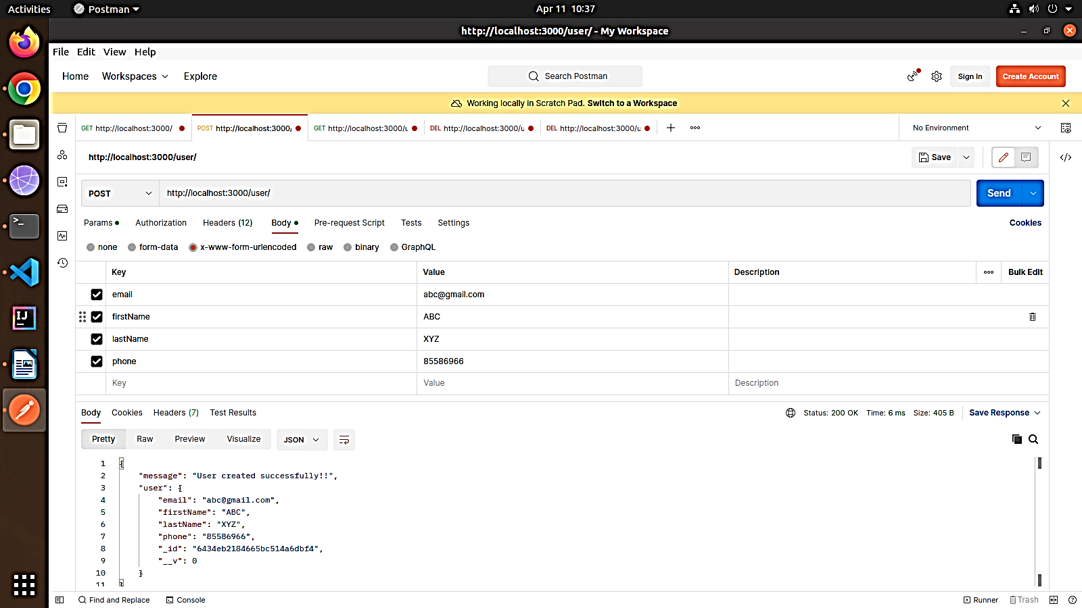**Create User:**

**Display Single User:**

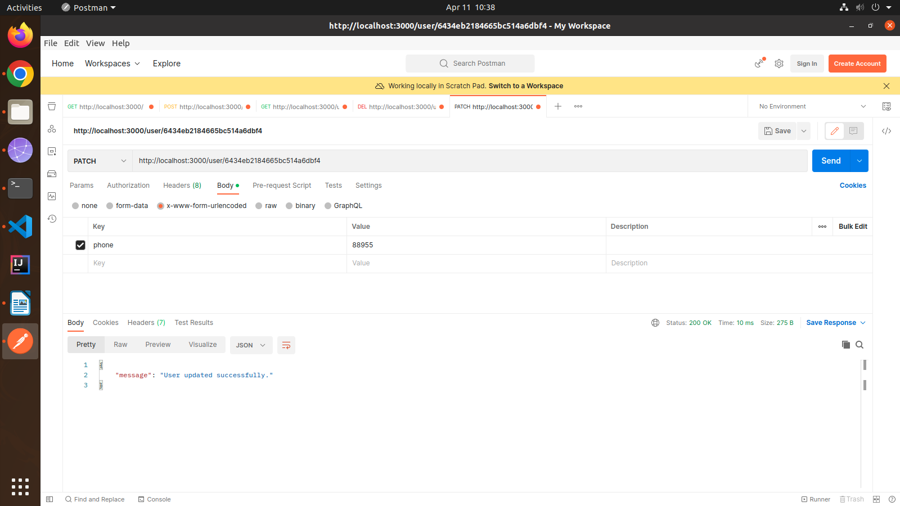**Update User:**

**Delete User:**

